Department of Computer science
Programme code:1601 Programme Name: M.Sc Computer science

Feedback analysis report for the year 2020-21 (Sem -I & Sem-II)

- Student Feedback
Number of Students gave the feedback: 65
 | Your previous knowledge for understanding the course is sufficient | Conceptual understanding of the course is easy | Is the course syllabus application oriented? | Syllabus is challenging | The course outcomes meeting Local /Regional/ Global needs/ | Overall rating of the course is Excellent
Agree | 43 | 42 | 42 | 28 | 42 | 43
Neutral | 8 | 5 | 9 | 8 | 9 | 8
Strongly agree | 14 | 18 | 14 | 29 | 14 | 14

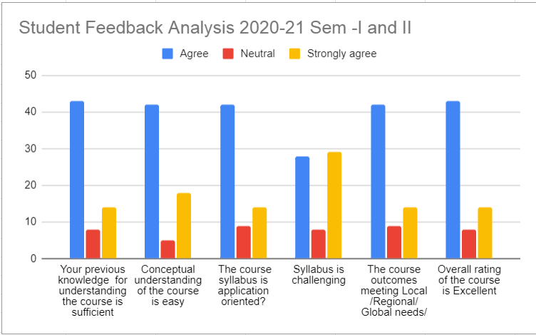

- Alumni Feedback
Number of Feedback Responses: 10

 | Your career goal is accomplished at the end of the course | Curriculum meets prerequisite and basic knowledge required for the career. | Adequate number of Guest lecture/ Seminars were conducted to enrich the curriculum | Design of the courses (subjects) encourages /motivates extra learning or self learning. | The course outcomes meeting Local /Regional/ Global needs/ | Overall rating of the course is Excellent
Agree | 3 | 2 | 2 | 4 | 2 | 4
Neutral | 4 | 4 | 4 | 2 | 5 | 2
Strongly agree | 3 | 4 | 4 | 4 | 3 | 4

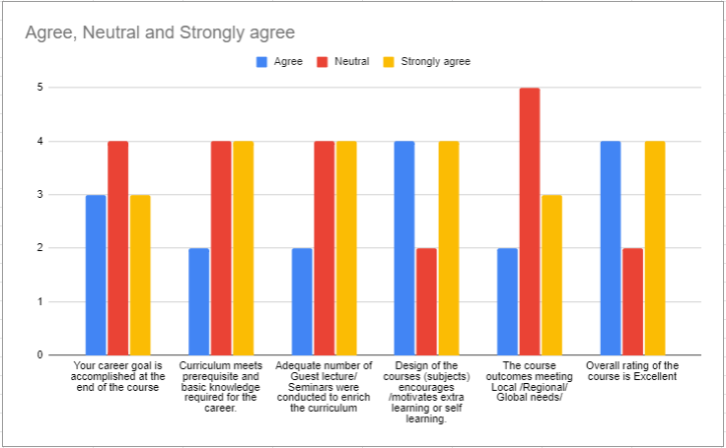

3. Parents feedback
Name of the parent/ Guardian | Regd. No. / Hall ticket No. of your ward | The ambience of the college for effective delivery of the academic process? | How do rate the courses in terms of their relevance to the latest and/or future technologies? | The curriculum contents were appropriate for the student for career and higher education | How do you rate the outcomes that your son/daughter has achieved from the courses? | How do you rate the college activities that help your son/daughter in getting jobs and placements? | How do you rate the transformation of your son/daughter after the completion of the course? | Any other expectations from the curriculum? | Suggestions for further Improvement
Valloji Pullaiah | 20174160116 | Excellent | Excellent | Very good | Very good | Very good | Very good | Na | Na
Rama Krishna Chaitanya | 20174160109 | Excellent | Excellent | Excellent | Excellent | Excellent | Excellent | Nothing | Nothing

4. Employer feedback
Name of the Employer / Industrialist | Name of the organization | How do you rate the sufficiency of syllabus content to bridge the gap between academia and industry | How do you rate the skills acquired from the curriculum to face the industry challenges/requirements | How do you rate the curriculum in relation to your current professional standards? | How do you rate the offering of electives in relation to technology advancements | How do you rate the skills acquired from the curriculum to face the industry challenges/requirements? | How do you rate the institute’s laboratory and equipment adequateness for practical exposure? | How do you rate the experimental list in getting ample placements in Industry? | Any other expectations from the curriculum? | Suggestions for further Improvement
K Satyanarayana | Koneru Lakshmaiah Education Foundation | Excellent | Excellent | Excellent | Excellent | Excellent | Excellent | Excellent | Good | Faculty Skills can be further improved
V UDAY KUMAR | Cognizant Technology Solutions | Excellent | Excellent | Excellent | Excellent | Excellent | Excellent | Excellent | Nothing | NA
Pradeep Raj Savarapu | Nokia Solutions and Networks | Very good | Very good | Very good | Very good | Very good | Very good | Very good | None | None

5. Teachers Feedback

Name of the teacher | How do you rate the suitability of syllabus for both slow and fast learners | How do you rate the availability of standard textbooks for the coverage of the syllabus | How do you rate the curriculum framed for entire programme | How do you rate the appropriateness of the sequence of the courses provided in the curriculum? | How do you rate the distribution of credits to the course ? | How do you rate the potential of the students in understanding the course objectives? | How do you rate syllabus content of the course in terms of burden on the students? | How do you rate the experimental list in stimulating the interest of the students in the subject? | Any other expectations from the curriculum? | Suggestions for further Improvement
G. Sridhar | Excellent | Excellent | Excellent | Excellent | Excellent | Excellent | Excellent | Excellent | More Practicals | Computers
Lakshmi Sarvani Videla | Excellent | Excellent | Excellent | Excellent | Excellent | Excellent | Excellent | Excellent | Nil | More computers
D P V PHANI RAJAKUMAR | Very good | Very good | Excellent | Excellent | Excellent | Excellent | Good | Excellent | Introducing New Traditional PG courses like MBA&MCA | Should need Placement officers or Introducing Internship
Jammi sarada lakshmi | Good | Good | Very good | Excellent | Excellent | Good | Average | Excellent | For some courses Syllabus and textbooks should be revised. | Maeket Demand courses should be added.syllabus needs to be revised.
Ch. Bharat Kumar | Excellent | Excellent | Excellent | Excellent | Excellent | Excellent | Excellent | Excellent | Nothing | Computers needed

